Name – Arshia Chandarki

Roll – CO3008

Lab Assignment 4

CREATE TABLE Students (

StudentID INT PRIMARY KEY,

StudentName VARCHAR(50) NOT NULL,

CourseID INT

);

CREATE TABLE Courses (

CourseID INT PRIMARY KEY,

CourseName VARCHAR(50) NOT NULL,

Credits INT

);

INSERT INTO Students (StudentID, StudentName, CourseID) VALUES

(1, 'Alice', 101);

INSERT INTO Students (StudentID, StudentName, CourseID) VALUES

(2, 'Bob', 102);

INSERT INTO Students (StudentID, StudentName, CourseID) VALUES

(3, 'Charlie', 101);

INSERT INTO Students (StudentID, StudentName, CourseID) VALUES

(4, 'David', NULL);

INSERT INTO Students (StudentID, StudentName, CourseID) VALUES

(5, 'Eva', 103);

SELECT \* FROM Students;

INSERT INTO Courses (CourseID, CourseName, Credits) VALUES

(101, 'Mathematics', 3);

INSERT INTO Courses (CourseID, CourseName, Credits) VALUES

(102, 'Physics', 4);

INSERT INTO Courses (CourseID, CourseName, Credits) VALUES

(103, 'Chemistry', 3);

INSERT INTO Courses (CourseID, CourseName, Credits) VALUES

(104, 'Biology', 2);

SELECT \* FROM Courses;

SELECT

Students.StudentID,

Students.StudentName,

Courses.CourseName

FROM

Students

INNER JOIN

Courses ON Students.CourseID = Courses.CourseID;

SELECT

Students.StudentID,

Students.StudentName,

Courses.CourseName

FROM

Students

LEFT OUTER JOIN

Courses ON Students.CourseID = Courses.CourseID;

SELECT

Students.StudentID,

Students.StudentName,

Courses.CourseName

FROM

Students

RIGHT OUTER JOIN

Courses ON Students.CourseID = Courses.CourseID;

SELECT

Students.StudentID,

Students.StudentName,

Courses.CourseName

FROM

Students

FULL OUTER JOIN

Courses ON Students.CourseID = Courses.CourseID;

SELECT

Students.StudentName,

Courses.CourseName

FROM

Students

CROSS JOIN

Courses;

SELECT

StudentID,

StudentName,

CourseName

FROM

Students

NATURAL JOIN

Courses;

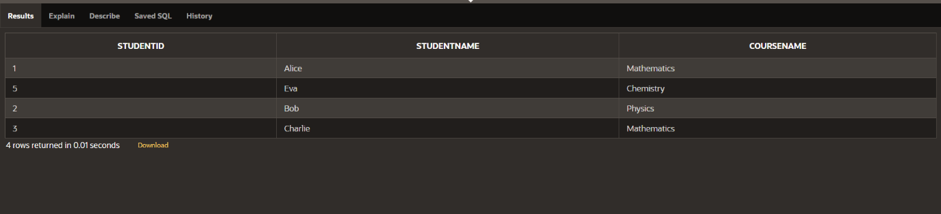

Inner Join

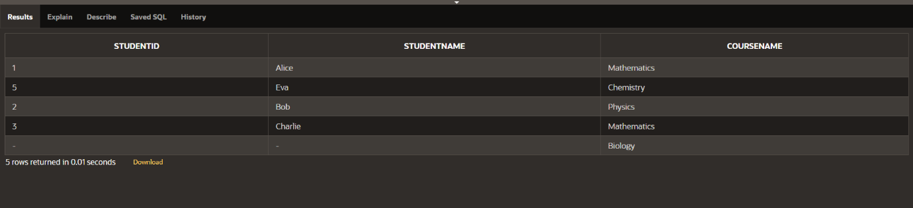

Right Outer Join

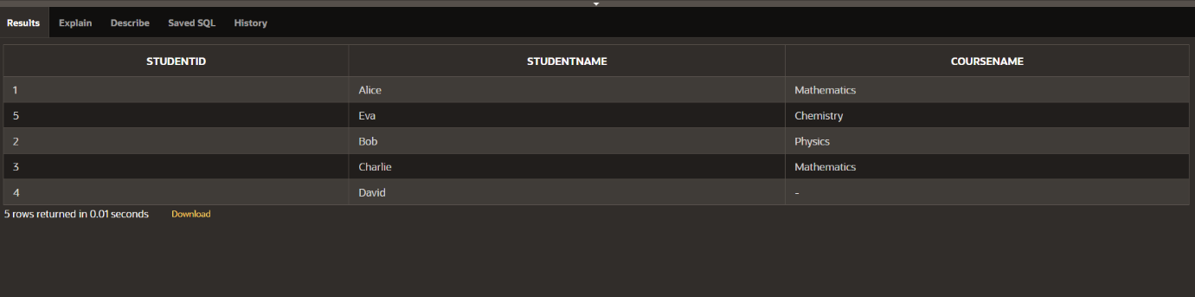

Left Outer Join

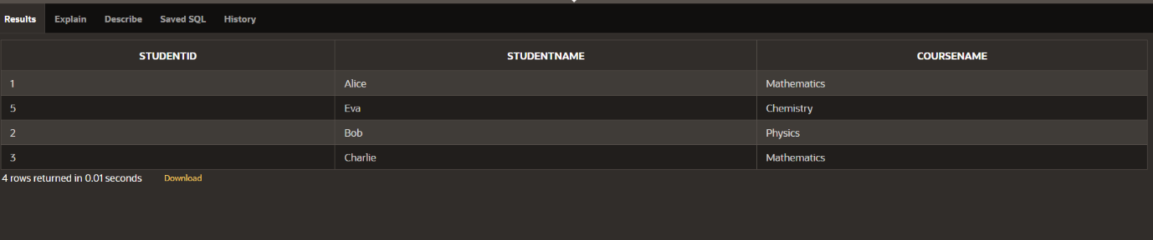

Natural Join

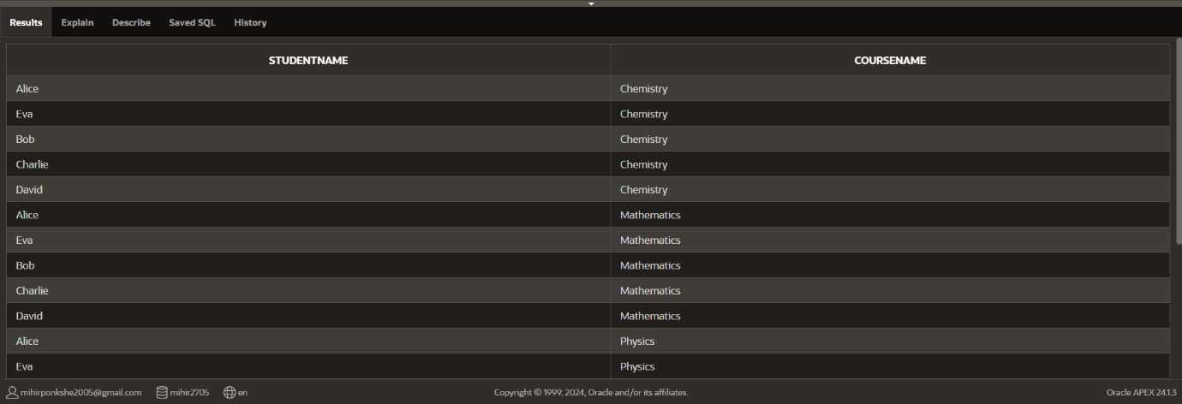

Cross Join

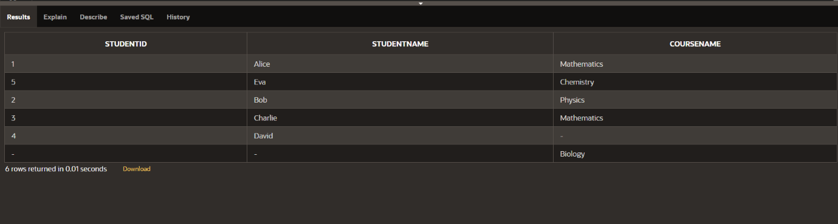

Full outer join